Willis Allstead

5/2/18

CS 491

Lab 7

**Community Detection**

[was unable to create/implement my own k-means algorithm in time]

Using Gephi:

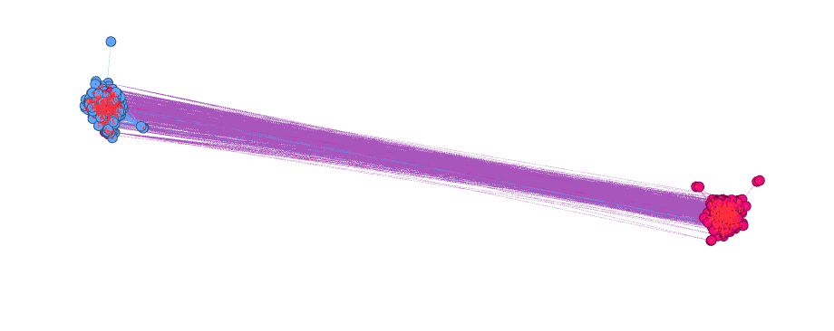

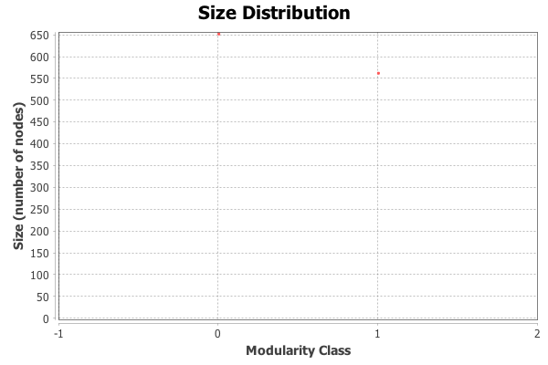

Gephi found 2 communities using modularity with a resolution of 2.

One was of size 664 and the other was of size 554.

|  |  |  |  |
| --- | --- | --- | --- |
|  | Correctly Labeled | Incorrectly Labeled | Total |
| Community 0 | 543 | 11 | 554 |
| Community 1 | 451 | 213 | 664 |
| Total | 994 | 224 | 1218 |

Community 1:

Precision = 543/994 = 0.546

Recall = 543/554 = 0.980

f-measure = (2*0.546*0.980)/(0.546+0.980) = 0.701

Community 2:

Precision = 451/994 = 0.454

Recall = 451/664 = 0.679

f-measure = (2*0.454*0.679)/( 0.454+0.679) = 0.544